**AuE 8930: Computing and Simulation for Autonomy**

**Homework 5**

***Submitted by- Priyanshu Rawat***

**Question 1)**

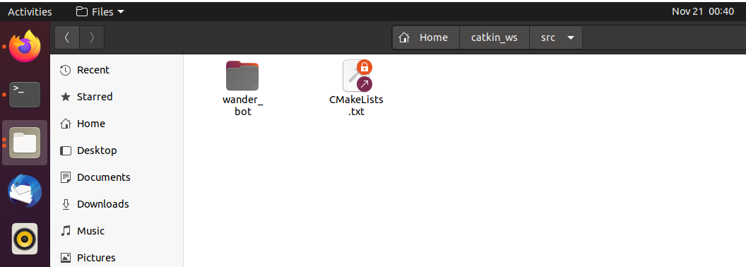

**Question 2)**

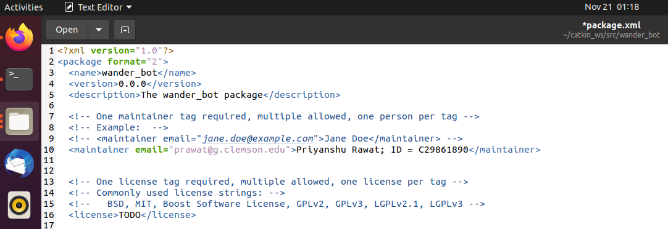

**Question 3,4,5 -**

<https://github.com/priyanshurawat1509/Homework5>

